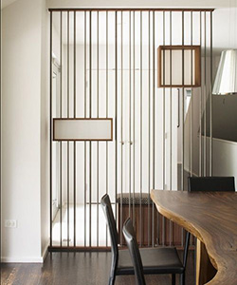

Stainless Unique Steel Divider

$93.99

Availability: In stock

**Description:**

A midcentury modern update on a traditional Asian design, this sleek and chic room divider is a sophisticated addition to any ensemble. Available in a curated selection of metallic finishes, this unit’s frame is crafted of solid pine wood, while rice-paper inspired white panels feature linear overlays. At 71" tall and 72" wide fully expanded, this room divider can be used to define space in an open concept room, or can be set in front of a large window for privacy. Rounding out the design, metal hinges make folding and storage a breeze when not in use.